1. Counting Elements

CODE:

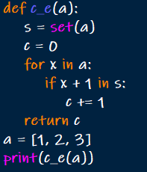

OUTPUT:



1. Perform String Shifts

CODE:

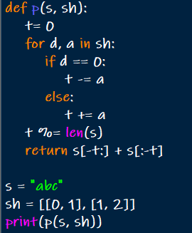

OUTPUT:



1. Leftmost Column with at Least a One

CODE:

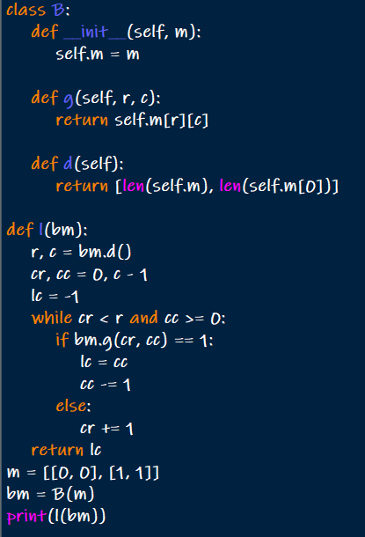

OUTPUT:



4.First Unique Number.

CODE:

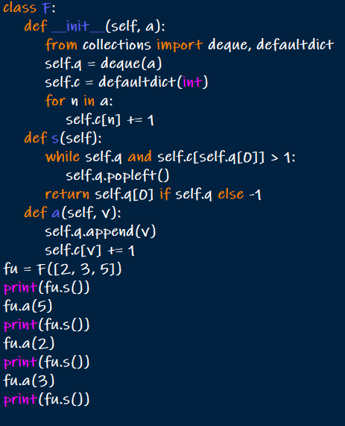

OUTPUT:

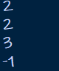

5Check If a String Is a Valid Sequence from Root to Leaves Path in a Binary Tree

CODE:

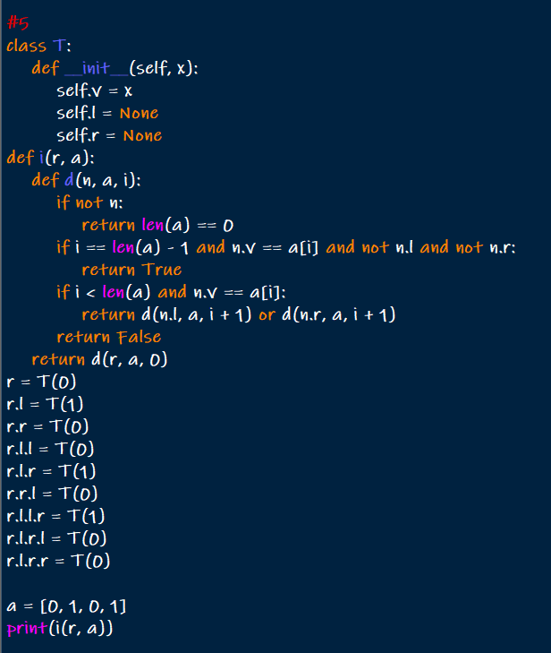

OUTPUT:



6.Kids With the Greatest Number of Candies

CODE:

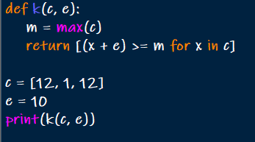

OUTPUT:



1. Max Difference You Can Get From Changing an Integer

CODE:

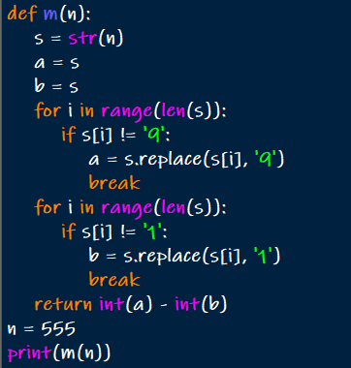

OUTPUT:



1. Check If a String Can Break Another String

CODE:

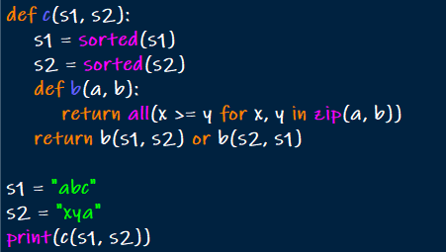

OUTPUT:



1. Number of Ways to Wear Different Hats to Each Other

CODE:

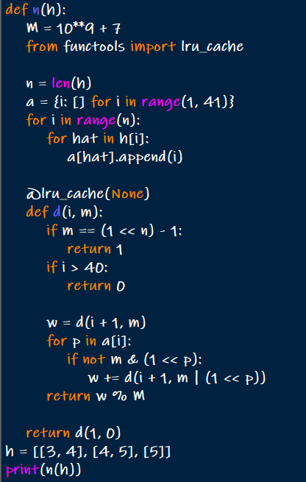

OUTPUT:



10.Destination City

CODE:

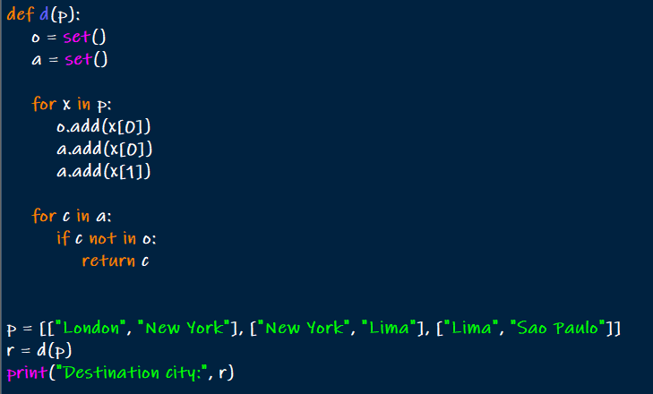

OUTPUT:

